**Week 3 Blog post**

**Topic -**

Week 3 – UI controls and actions

One app was created in this week – The memory game app

**Snapshots of the final product -**

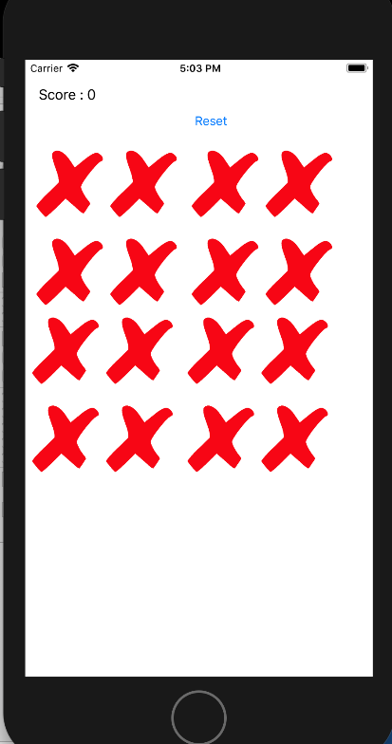

Fig 17: Snapshot of the initial simulator view of the app after compilation.

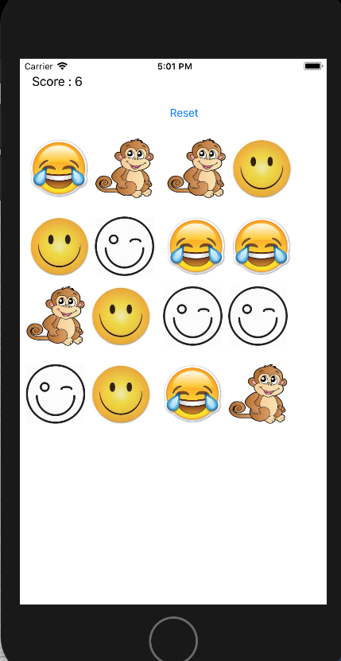

Fig 18: Final view of the app after the game has been played with the user scoring 6.

**How I implemented –**

This app needed a lot of work compared to week 2. For this app first I added five images in my assets file, images like smiley face, winking face , monkey, laughing face and the default image ‘X’. I had added 16 buttons and each button with a different tag value with the initial image set as ‘X’. Also in the main storyboard I added a label for updating the score and a reset button so that the user can play again. There was a common function for all the buttons, for finding the match. Also I created a outlet collection for reset purpose. I also added a function called rotate that makes an animation like feature, which makes the button rotate. The main functions are shown below.

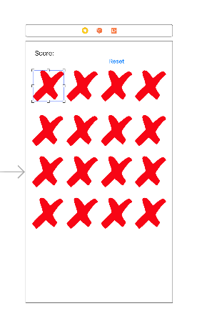

Fig 19: The main storyboard screen.

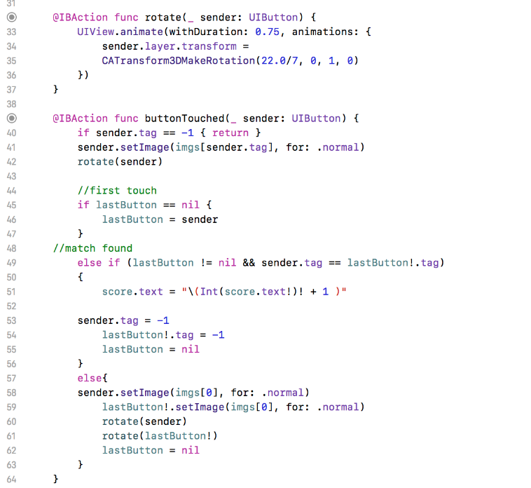

Fig 20: Code snipped for the main function that gets triggered everytime the user taps any button.

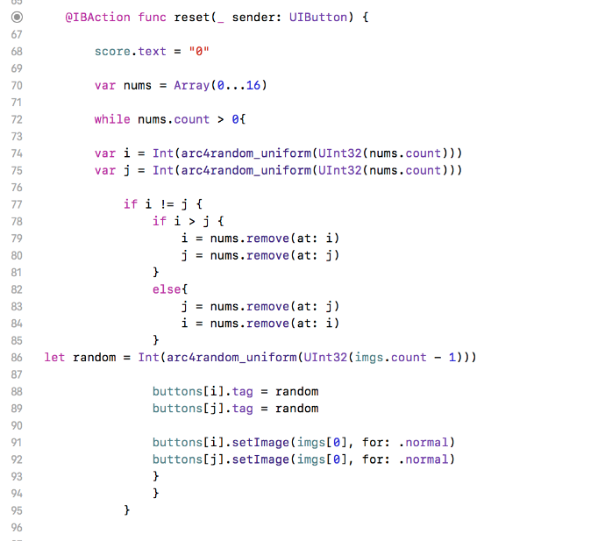

Fig 21: The reset function that resets all value so that the user can play again

**Reflection –**

This week I got to learn about button actions, outlet collections and how to change and set images. This not only helped in the learning process but also helped in completing almost fifty percent of the tic tac toe assignment. While doing this lab I faced a lot of problems and overcoming those problems is what helped me learn more. This weeks lab helped me to set the images in my assignment app and also the reset button function is what I used in the assignment. This app was the first mini game app that I created so I got more excited for the coming weeks.